**Leader Overview**

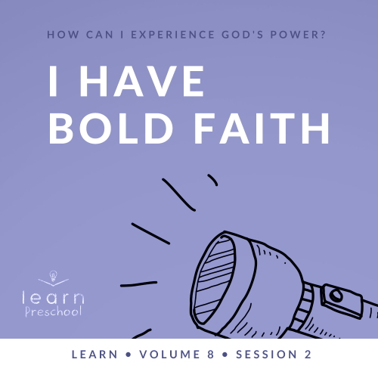

**Volume Overview**

**How can I experience God’s power?**

*When we think of power, we might think of physical strength or mental toughness. While God surely wants us to experience physical health and clarity of mind, He desires that we experience His supernatural power too.*

*In the Bible, it’s clear that our God—revealed through the Father, the Son and the Holy Spirit—is powerful. He spoke the world into existence and sustains the universe by the power of His Word (*[*Hebrews 1:3*](https://ref.ly/logosref/Bible.Heb1.3)*). God displayed His power in many ways in the Old Testament for His people. In the New Testament, Jesus’ life and works revealed His power over sickness, spiritual forces, and even the grave. After Jesus’ resurrection, God sent the Holy Spirit so we could have the power to do kingdom work today (*[*Acts 1:8*](https://ref.ly/logosref/Bible.Ac1.8)*). Clearly, God is powerful! But how do you and I experience His power? That’s the question we’ll explore in this volume.*

**Session Overview**

**I Have Bold Faith**

*In this* **Learn** *session, preschoolers will explore God’s supreme power. He has the ability to work outside our understanding, both in nature and in our situations. Elijah and Elisha both experienced God parting the Jordan River, as well as empowering them in supernatural ways to accomplish His purposes. God has also promised to help us, so we can expect Him to do great things in our life, too.*

**Bible Lesson**

Elisha’s Double Portion

[2 Kings 2:6–15](https://ref.ly/logosref/Bible.2Ki2.6-15)

**Faith Fact**

I believe God can do great things.

**Faith Verse**

[John 14:12](https://ref.ly/logosref/Bible.Jn14.12) (NLT)

“I tell you the truth, anyone who believes in me will do the same works I have done.”

**Preparing for the Session**

**Leader Preparation Time: 20–25 Minutes**

|  |
| --- |
| ***You Will Need***  ***Preservice Activities***  *• Pitcher of water*  *• Small cups*  *• Bowl or container*  *• Paper towels*  *• Snacks, two portions per kid (cookies, cheese sticks, crackers, etc.)*  ***Large Group***  *• Bible*  *• Worship songs (Song suggestions: “My God Is So Big” by Hosanna Kids; “What a Mighty God We Serve” by Christian Songs for Kids; “Love the Lord” by CJ and Friends)*  *• For groups not using a phone or tablet only, add:*  *• Projector or TV*  *• Laptop*  *•* ***Faith Fact Sound video*** *(bell ringing)*  *•* ***Faith Fact Slide***  *•* ***Faith Verse Slide***  *•* ***Bible Lesson Video A***  *•* ***Bible Lesson Video B***  ***Small Group***  *•* ***Small Group Activity Page****, one per kid*  *• Crayons or markers*  *• Two different colors of floor-safe tape*  *• Towel*  *•* ***Small Group Hands-On Learning Page****, one per five kids*  *• Card stock*  *• Scissors*  *• Markers or crayons*  *• Stapler*  *• Optional: Stickers and other fun things for decoration*  *To access session content and videos from a computer, visit:* [*BibleEngagementProject.com/downloads*](https://bibleengagementproject.com/downloads) |
| ***Getting Ready***  ***Preservice Activities***  *• Set out toys and snacks.*  ***Large Group***  *• Download videos and slides if needed.*  *• Select worship song(s) and have them ready to play.*  ***Small Group***  *• Choose a space where kids can hide to play Hide and Seek.*  *• Print copies of the* ***Small Group Activity Page****, one per kid.*  *• With one color of tape, make a large rectangle on the floor to represent the Jordan River. Make it big enough for all kids to stand inside.*  *• Using the second color of tape, add two more tape lines to represent the dry ground within the rectangle.*  *• Using card stock, print copies of the* ***Small Group Hands-On Learning Page****, one per five kids.*  *• Cut apart the wristbands.*  ***First time leading* Learn *for Preschool? Check out the*** [**Facilitator Guide**](https://0b769b0ed3569ef9d18b-f88d8272f61086866d50d048b43ef630.ssl.cf2.rackcdn.com/sites/biblengagementproject/Listen_Facilitator_Guide.pdf)**.** |

**Preservice Activities**

*See what’s needed at the beginning of the session.*

**Bible Story Warm-Up**

I’m going to give you clues so you can guess what I’m thinking. When you think you know what it is, raise your hand, but don’t say anything. Ready? *(Group response)*

This was one of the first things God created. We see it come from the faucet in the kitchen. It fills our bathtubs. Our bodies need it every single day. I see lots of hands. Do you know what I’m thinking? What is it? *(Allow responses.)*

• *Hold up the pitcher of water.*

We use water for so many things in our life. I’m going to demonstrate one of those things right now.

• *Pour water into a cup and take a drink of water.*

What did I just do with water? *(Group response)* Does anyone else want a cup of water? *(Group response)*

• *Hand out cups of water to the kids.*

• *Hold the bowl and the pitcher of water.*

Now, let’s see something else we use water for. Is anyone willing to volunteer before you know exactly what we’re going to do? *(Allow responses.)*

• *Instruct volunteer to hold their hands over bowl.*

• *Pour small amount of water over their hands. Let them dry their hands with a paper towel.*

We use water to wash all kinds of things: our hands, our bodies, our clothes, and the floors. Who else wants to feel the water on your hands?

• *Pour water over hands of each kid who wants to feel the water. Let them dry their hands with paper towels.*

There’s something else that’s really fun that we do in big pools or lakes of water. What do you think it is? *(Group response)* Yes, it’s swimming. Who created water for all of these uses? *(Group response)* Isn’t God amazing that He thought of how we would need water and what we could use it for? *(Group response)*

Have any of you ever been to a river, lake, or creek, or seen pictures of one?

What did you notice about the water?

What are some other things you know about rivers, lakes, or creeks?

Our Bible story involves a miracle with water in a big river. Actually, there are two miracles at this river, so you’ll have to listen for them. God did something really great for two men named Elijah and Elisha, and God can do great things in your life, too.

**Snack**

**Double Portion (Snacks that can be divided into two equal parts)**

*Hand out one small portion of the snack to the kids. As kids are eating the snack, share the following:*

Today, we’ll learn about something Elisha really wanted. Raise your hand if you’ve ever wanted something so much that it was all you could think about. *(Group response)* Maybe you wanted something special for your birthday or Christmas. Maybe you wanted something really big like a baby brother or sister. Raise your hand if you asked for something over and over again. *(Group response)*

In our Bible story, Elisha was learning about God from Elijah. Their names sound alike, don’t they? Elisha spent time with Elijah, and Elisha wanted a double portion of Elijah’s spirit. That means Elisha wanted to be close to God and hear God’s voice like Elijah did. Let me show you what a double portion is. How many of you got some snack already? *(Group response)* You got one portion. Now, I’m going to give you another one. That’s a double portion because you got more.

• *Give kids another serving of the snack.*

Elisha wanted to be like Elijah and know God more than anything else. We’ll find out more in our Bible story time.

**Free Play**

*Any extra time can be spent playing with toys.*

**Transition**

*A few minutes before service begins have kids make their way to the large group area and sit in their designated areas.*

**Large Group**

**25 Minutes**

*See what’s needed at the beginning of the session.*

**Introduction**

We’re going to have such a great time learning about God and His Word. *(Hold up Bible.)* Everyone, pretend you’re opening a Bible and then carefully set it on the floor in front of you.

• *Lead kids to do these actions.*

If you’re ready to learn about our Bible story today, let’s jump into God’s Word.

• *Demonstrate jumping into the pretend Bible on the floor in front of you.*

We get to explore an amazing Bible story today. There are two men in it whose names sound very much alike. Say their names with me: Elijah *(Group response)* and Elisha *(Group response).* Elijah was older. Last time, we heard a Bible story about how God sent food to him. Elisha was probably younger than Elijah. He wanted to hear God’s voice and give God’s messages to people just like Elijah did. God did something really great for Elijah and Elisha, and I know God does great things for us too.

**Faith Fact**

Hey, I think that sounds a lot like our Faith Fact today. **I believe God can do great things.**

• *Show the* ***Faith Fact Slide.***



Let’s say our Faith Fact together. **I believe God can do great things**. Because we’re saying God can do great things, let’s spread out our arms and feet as far as we can like a jumping jack when we say it. **I believe God can do great things**. That was so good! Now, bring your arms and feet in again close like you’re a pencil and say our Faith Fact one more time. **I believe God can do great things**. Great job!

**Bible Time**

I love being in church with all of you and learning about who God is and how much He loves us. Let’s check in with Lizzy and Grandpa to hear what they’re learning about God today.

• *Play* ***Bible Lesson Video A****.*

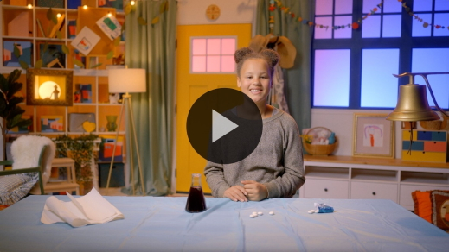

Great job! I love that our Faith Verse reminds us that God did great things for the people in the Bible. He also does great things for people like you and me who follow Him today.

**Worship**

God can do great things because He is the strongest and most powerful being ever. He has power over all creation. God never makes us worship Him. That’s a choice we get to make because we love Him so much. When we worship God, we get to tell Him how great He is.

**Praise**

Are you glad God is here with us? Touch your toes down low. *(Group response)*

Are you glad God can do great things? Stretch your arms out wide. *(Group response)*

Who wants to tell God thank You? Clap your hands. *(Group response)*

**Sing**

We can also worship God with our voice. Singing is a way to worship God that people were doing all the way back in Bible times.

• *Lead the kids in singing one or two songs. See song suggestions at the beginning of the session.*

**Prayer**

Now, we get to talk to God. Let’s bow our heads and pray.

|  |
| --- |
| God, thank You for how great You are. You do great things because You are great in power and strength. You help us. You speak to us in powerful ways. I ask that You help us do the things You want us to do. I ask that You do great things in the life of everyone who is here today. Amen. |

**Bible Time cont’d**

I wonder what Lizzy has been doing since we practiced the Faith Verse with her. Wave your hand at me if you think we should see what she’s been up to. *(Group response)*

• *Play* ***Bible Lesson Video B.***

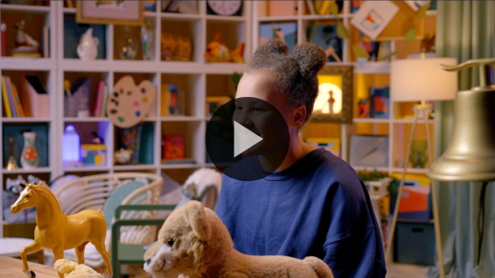

Wow! Can you believe God can split a big river right down the middle? *(Group response)*. He not only did it for Elijah but He also did it for Elisha. That’s twice God split the river. I didn’t get to see God split the Jordan River, but I have seen God do great things in my life. God has helped me when I needed it, and I have heard His voice leading me where I should go.

• *Tell a personal story of something great you have seen God do.*

• *If you can’t think of a personal story, tell the story of Oral Spence Boyer, missionary to Brazil. There were no crops in northeast Brazil because it hadn’t rained in a very long time. The missionary traveled several days to buy large bags of rice and beans to feed his family for several weeks. When he came back to his village, he saw how hungry everyone was. He prayed to God for a miracle. Then, he told everyone in the village to come get rice and beans for their families. Families came to get rice and beans every day, and the bags were never empty. God did a miracle and made the rice and beans last for a month until the rains came and other food was available.*

Now, I want to see how well you all were listening to the Bible story. Use your fingers to wiggle your ears at me if you were listening to the story. *(Group response)* What were the names of the two men in our Bible story? *(Group response)* Yes, Elijah and Elisha are their names. When they came to the Jordan River, what did Elijah take off and slap on the water? *(Group response)* His cape is right. Who did something great for Elijah and Elisha because He is great? *(Group response)* God did. Your listening ears must have been turned on because you learned that Bible story so well.

**Response Time**

• *Play a worship song quietly.*

Let’s take some time to respond to what we’ve learned today. Let’s put our hands over our heart and think about the great things God has done for each one of us. God has given you good gifts. Let’s thank Him for how strong and powerful He is. What is something you’d like to thank God for? *(Allow responses.)*

• *Optional: Have the kids repeat phrases of the prayer after you.*

|  |
| --- |
| Dear God, thank You for all the great things You have done for the people in the Bible and for us. Thank You for giving us people who love us and care for us. Thank You for giving us a church where we are loved and can learn more about You. Amen. |

**Faith Verse**

Learning Bible verses helps us remember that God can do great things. Let’s say our Faith Verse and do the actions together.

[John 14:12](https://ref.ly/logosref/Bible.Jn14.12) (NLT)

“I tell you the truth, anyone who believes in me will do the same works I have done.”

• *Show the* ***Faith Verse Slide****.*

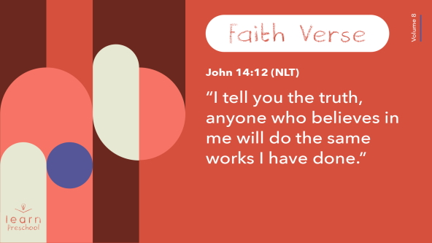

You’re learning our Faith Verse so well! Point to yourself and say, “I am awesome!” *(Group response)*

**Closing**

Today, did you learn how great God is? *(Group response)* I’ve had so much fun with you, praising God and worshipping Him. We’ve heard how God parted the Jordan River for Elisha and Elijah. God does great things for us, too.

• *Play the* ***Faith Fact Sound*** *video (bell ringing).*

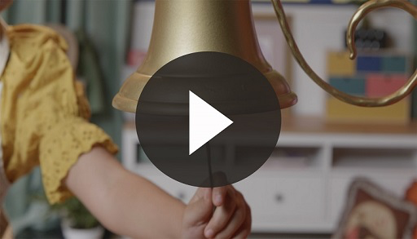

We’re going to practice our Faith Fact one more time. **I believe God can do great things.**

• *Show the* ***Faith Fact Slide.***



Let’s use our greatest voices to say it one more time. **I believe God can do great things.**

**Dismissal to Small Groups**

It’s time to do some fun activities with your friends in small groups.

• *Dismiss the kids by groups*.

|  |
| --- |
| ***Leader Tip:*** *This can be done by assigning color teams or by age groups. Note that some young preschoolers may not know their age. Using a colored sticker, jersey, or wristband will help separate the kids and help identify their small groups.* |

**Small Group**

**25 Minutes**

*See supplies and prep instructions at beginning of session or in each activity below.*

|  |
| --- |
| ***Leader Tip****: Small groups can alternate to each circle, or all groups can do each activity at the same time. If you choose to alternate, you will need at least one leader per circle.* |

**Circle 1**

**Group Connection**

**Hide and Seek**

• *Choose a space where kids can hide to play this game.*

The more we learn about the Bible, the more we discover how amazing God is. Elijah showed Elisha the great things God does, and I love teaching you about them. Let’s play a game where I will be Elijah, and you’ll take turns being Elisha. Together, we’ll tell others about God. Elisha and I will count to ten while you hide in our room. When Elisha and I find you, you’ll run back here and sit down until we’ve found everyone.

• *Modify the game if needed, including letting everyone hide an object, if the space isn’t available to play hide and seek safely.*

When we’re all together, Elisha and I will preach God’s Word to you by saying our Faith Verse. Then, we’ll say our Faith Verse together to celebrate that everyone has heard about God. Let’s say our verse together before we begin.

• *Lead kids in saying the verse.*

[John 14:12](https://ref.ly/logosref/Bible.Jn14.12) (NLT)

“I tell you the truth, anyone who believes in me will do the same works I have done.”

• *Choose one kid to be Elisha. Instruct the other kids to hide.*

• *Count to ten and then find the kids.*

• *Repeat until every kid has had a turn as Elisha and led in saying the Faith Verse.*

That was fun! It feels so good to tell others about God, so they can feel His love and know the great things He does.

**Circle 2**

**Activity Page Time**

**Path through the River**

|  |
| --- |
| ***You Will Need***  *•* ***Small Group Activity Page****, one per kid*  *• Crayons or markers*  ***Getting Ready***  *• Print copies of the* ***Small Group Activity Page****, one per kid.* |

Elijah had a cape at the beginning of our Bible story today. Let’s use our imagination. Choose a color for Elijah’s cape.

• *Let kids choose one crayon or marker.*

• *Hand out a copy of the* ***Small Group Activity Page*** *to each kid.*

In our Bible story, Elijah and Elisha were traveling when they came to a river. Does anyone remember the name of the river they came to? *(Allow responses.)* Instead of the men swimming across the Jordan River, God did a great thing for them. What did God do when Elijah slapped his cape on the water? *(Allow responses.)*

In the first picture, we can see that God parted the river for Elijah. Can you point to his cape? *(Group response)* Go ahead and color his cape in the first picture. *(Group response)* Elijah and Elisha could walk through the river because God did a great thing for them.

Then, Elisha saw Elijah taken to heaven in a very special way. Who remembers what Lizzy said happened? *(Allow responses.)* Our second picture shows what might have happened when Elijah went to heaven. Did he take his cape with him? *(Group response)* No, his cape was left behind. Can you color the cape in the second picture? *(Group response)*

Elisha picked up Elijah’s cape. He wanted God to help him do great things just like Elijah. Can you color the cape in the third picture? *(Group response)* What is Elisha doing with it? *(Allow responses.)*

God parted the river for Elisha. Both Elijah and Elisha showed us that our Faith Fact is true. Say it with me. **I believe God can do great things.** As you color these pictures, think of the great things God has done for you.

• *Give kids time to finish coloring the pictures.*

**Circle 3**

**Feet-to-Floor Game Time**

**Parting the Waters**

|  |
| --- |
| ***You Will Need***  *• Two different colors of floor-safe tape*  *• Towel*  ***Getting Ready***  *• With one color of tape, make a large rectangle on the floor to represent the Jordan River. Make it big enough for all kids to stand inside.*  *• Using the second color of tape, add two more tape lines to represent the dry ground within the rectangle.* |

From our Bible story, what great thing did God do when Elijah and Elisha each slapped the cape on the Jordan River? *(Allow responses.)* Yes! Isn’t that amazing how God parted the river so they could walk through? God is so great, and He does great things.

For this game, you’ll be the water of the Jordan River. Look at the floor. Does anyone see anything different from usual? *(Group response)* There’s tape on the floor. You’re going to stand inside the big box of tape as the water in the Jordan River. I’ll ask one of you at a time to be Elisha. We’ll play until everyone gets a turn.

Do you see the two lines that are a different color of tape in the middle of the box? *(Group response)* When Elisha slaps the cape on the water, the water is going to run behind the middle tape lines because God is parting the waters. Then, Elisha will walk through the river on dry ground. I think our Elisha should say the Faith Fact when walking through the water. Let’s practice the Faith Fact. **I believe God can do great things.**

• *Choose a kid to be Elisha and give them the towel to represent the cape.*

• *Have the other kids stand in the rectangle.*

So all of you are going to be the water. Is water *(say this quietly)* sometimes quiet and *(say this loudly)* sometimes loud? *(Group response)* So when you’re the water, keep your eyes on me. When my hands are close together like this *(put palms flat on top of each other)* that means the water is quiet. You’re going to make a gentle and quiet “swish, swish” with your voice to sound like the water. When my hands are apart like this *(raise one palm above the other),* that means the water is louder. You’re going to make louder wave sounds

like the water.

• *Demonstrate what you want the kids to do and have them practice with you.*

Great job! Now, who remembers what you’re going to do when Elisha slaps the water with the coat? *(Allow responses.)* Yes, you’re going to get behind the tape line because God is doing a great thing and parting the Jordan River. Are you ready?

• *Move your hands to make water be quiet while Elisha gets ready to slap the coat on the floor.*

• *Help Elisha say the Faith Fact as needed*.

• *Repeat until everyone has had a turn.*

**Circle 4**

**Hands-On Learning**

**Faith Fact Wristbands**

|  |
| --- |
| ***You Will Need***  *•* ***Small Group Hands-On Learning Page****, one per five kids*  *• Card stock*  *• Scissors*  *• Markers or crayons*  *• Stapler*  *• Optional: Stickers and other fun things for decoration*  ***Getting Ready***  *• Using card stock, print copies of the* ***Small Group Hands-On Learning Page****, one per five kids.*  *• Cut apart the wristbands.* |

Today, we’re going to make a craft to remind us that God can do great things. Who remembers what Elijah was wearing over his clothes that he gave to Elisha? It’s what they slapped on the water when they asked God to part the Jordan River. *(Group response)* Elijah had a special cape he wore. Capes would be pretty big for everyone to make, but it’s a good thing to have something to wear to remind us how great God is.

• *Hold up a wristband cut from the* ***Small Group Hands-On Learning Page****.*

You’ll get to wear one of these home on your wrist, but first let’s read and decorate them. They have our Faith Fact on them. What does it say? **I believe God can do great things.** Great job!

What picture do you see on the bracelet? *(Allow responses.)* The Bible is the best place to learn about God doing great things. You get to use the creativity that God has gifted you with to color the Bible. Maybe God created you to love a certain color. Use it to color all over the Bible. You get to decorate this any way you want to.

• *Hand out the wristbands from the* ***Small Group Hands-On Learning Page*** *and crayons or markers. Let kids decorate their own wristband.*

• *Use a stapler to close the wristband on each kid’s wrist when finished.*

I love seeing how you decorated your wristbands! They’re so colorful and creative. When you wear it home, you can tell everyone about the miracle God did when He parted the Jordan River for Elijah and Elisha.

**Dismissal**

• *Play the* ***Faith Fact Sound*** *video (bell ringing).*



• *Show the* ***Faith Fact Slide.***



That’s our Faith Fact sound! Let’s say it one last time before we go. **I believe God can do great things.** I had such a great time exploring the Bible with you. I’ll see you next time!

• *Send home the* ***Small Group Activity Page*** *and the wristband with each kid.*

• *Remind parents that there are* ***Family Devotions*** *available on the app to do with their kid.*

• *Tell everyone the date and time for the next session.*